**Career Episode 1**

**Thyristor Switched Capacitor and Thyristor Controlled Reactor based system for VAR compensation on Load side.**

1. **Introduction**

|  |  |
| --- | --- |
| Chronology | July 13, 2021 |
| Name of the Organization | Jawaharlal Nehru Technological University |
| Location | Kakinada, Andhra Pradesh, India |
| College | Vigan Institute of Information Technology |
| Program | Department of Electrical & Electronics Engineering |
| Subject | Thyristor Switched Capacitor and Thyristor Controlled Reactor based system for VAR compensation on Load side. |
| Supervisor |  |

1. **Background**

**CE1.1**

VAR compensation is a methodology to manage reactive power efficiently. Static VAR is a system which maintains load variation and provides flexibility to the model. Static VAR compensator consists of devices which performs functionality of supplying reactive power in high voltage transmission networks. SVC enhances the power factor of model and stabilizes the system. Thyristor switched capacitor is a device which consists of Thyristor valves having bidirectional characteristics and used for switching. Thyristor controlled reactor is a device which consists of fixed inductance and thyristors valves. TCR possesses high current conduction and high voltage withstanding capability. Firing angle control mechanism is performed by Thyristors. MATLAB/SIMULINK is a design and simulation software essential for model development and simulation purpose.

In the paper, a Thyristor Switched Capacitor along with the Thyristor Controlled Reactor was designed to measure the power factor of the system to a unit for the Static VAR compensator. The objective of the project was to design and simulate thyristor switched capacitor and thyristor controlled reactor based static VAR compensator using MATLAB/SIMULINK. The research about the required components was performed via journals, literature reviews, videos etc. The components were selected as per the requirement of project. The configuration and design was made for the proposed design. The design of the model was constructed using simulation software named MATLAB/SIMULINK. The parameters were set for the simulation and then simulation was executed. The evaluation was performed on the basis of simulation results. Finally, the conclusion was drafted on the basis of evaluation.

**CE1.2 Objective**

The objective of the project was to design and simulate thyristor switched capacitor and thyristor controlled reactor based static VAR compensator using MATLAB/SIMULINK. Other additional objectives were:

* To enhance reliability by fulfilling reactive power needs demanded by load.
* To resolve the issue VAR over-compensation.

**CE1.3 Nature of Work**

I researched about the components required in the project. I finalized the components as per the requirement. I designed varying load diagram, capacitors banks diagram, TCR block diagram and overall proposed model of the system using MATLAB/SIMULINK. I researched the setup and uses of the program's thyristor switched capacitor. I learned well about thyristor-controlled reactor and how it is used in the systems. I set the appropriate parameters for the simulation of the prepared model. I simulated the model using MATLAB/SIMULINK. I evaluated step change VAR behavior of source, load, capacitor banks and inductor coil separately. Also, I analyzed power factor of line to check amount of overcompensated VAR consumed by TCR branch inductor. On the basis of evaluation done, I drafted the final conclusion.

**CE1.4 Organizational Chart**

**Hierarchy Chart**

**CE1.5 Duties**

* To study about the components used in the system.
* To finalize the optimal components as per the requirements of the project.
* To design system model using MATLAB/SIMULINK.
* To set parametric value and simulate the design model.
* To evaluate the simulation results under different conditions.
* To draft conclusion on the basis of results obtained.

1. **PEA**

**CE1.6**

I began the project work by researching about the project itself along with its requirements. I researched about the required components via journals, literature reviews, videos etc. I researched about static VAR compensator along with its characteristics, configurations, operational methodology, advantages and disadvantages. I studied about configuration and applications of thyristor switched capacitor that was used in the system. I acquired information about thyristor controlled reactor along with its application. I gained knowledge about load line distribution in the power system. I researched about microcontroller that was used in the system. I studied about commands, working methodology of the designing and simulation software that was used in the system. I also researched about optimal simulation parameters used during the simulation of model. I acquired information about evaluation metrics of the proposed system. I studied about methods for optimization of the project.

**CE1.7**

After the preliminary research phase, I headed into material selection process. I finalized the components as per the requirement of the project. I selected static VAR compensator for reactive power supply in transmission network of high voltage and to provide stability to the system. I selected thyristor switched capacitor to provide controlled switching mechanism in the system. I decided to use thyristor controlled reactor to fulfill the criteria of higher voltage level because of its higher current conduction and higher voltage withstanding capability. I chose PID controller to gain control over thyristors firing angle and to test the efficiency of varying load during simulation. I selected MATLAB/SIMULINK for designing the proposed model and simulating it under different conditions. I decided to use supply voltage, frequency, resistive element and load as simulation parameters of the proposed system. I decided to use line power factor and step change behavior of VAR in terms of load, source, capacitor bank and inductor as evaluation metrics.

**CE1.8**

After material selection phase, I headed into model designing phase of proposed system. I designed SVC model diagram of proposed system. For that, I initially designed capacitor bank block and put line resistance in series and connected the source. I designed TCR block and connected it with variable load. Also, I connected capacitor bank block with variable load block to import the VAR need value from the variable load block. I constructed line value block and fed current and voltage parameter. I designed blocks which recorded the amount of VAR generated and VAR consumed by capacitor bank blocks and TCR block respectively. I inputted firing signal to the TCR block. I connected Capacitor bank block with scope to display graphical output of the generated VAR. Also, I connected TCR block and linevalue block with scope to display respective output. I joined VAR generated block variable load block with seconday source block. Also, I joined VAR consumed block with secondary source which provided input to another reciever block.

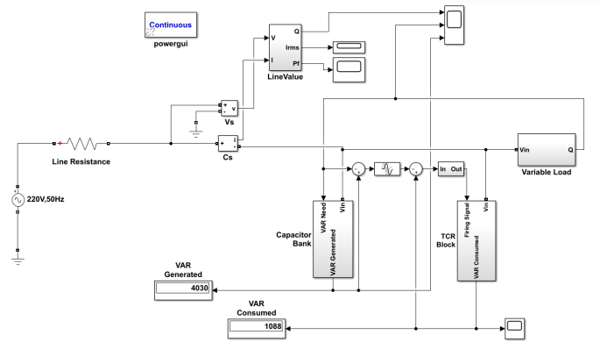

Fig5: SVC model of the proposed system using MATLAB/SIMULINK.

CE1.9

Then, I designed the model by the help of MATLAB/SIMULINK. I designed capacitor bank which contained 5 capacitor unit and each block generated equal output value. I designed the variation of loads design by using three loads each having capacity of 5KW, 3KVAR. Initially, I connected only one set of load and other two sets of load were switched automatically on specified time interval. For TCR block, I designed gate signal generator considering firing signal input from bidirectional thyristor to generate ON gate signal for consumption of extreme VAR. I used PI controller to import excess generated VAR and send signal to gate signal generator. I placed 2.5KVAR size of inductor for consumption of excess VAR. I set parametric value of supply voltage, frequency and resistive element for the simulation. I set switching time interval for the loads that was connected later in the system.

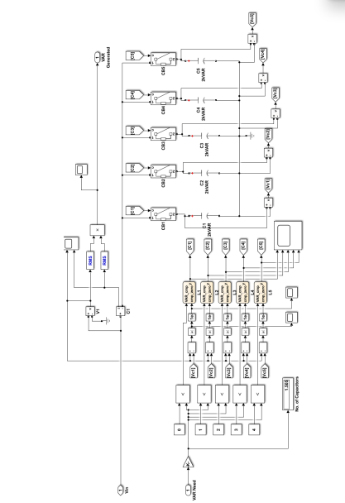

Fig2: block of capacitor bank of the proposed system

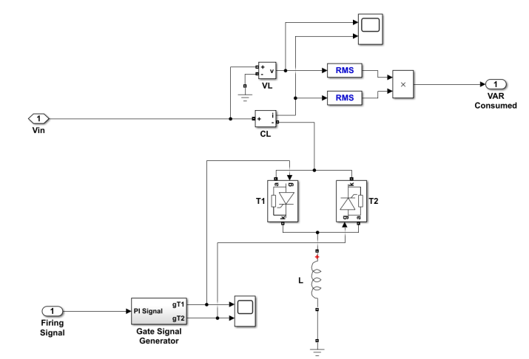

Fig3: TCR block of the system.

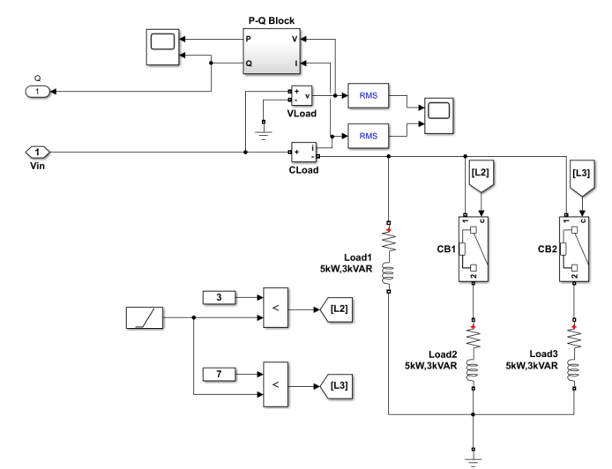

Fig4: variation of load block used in the proposed system.

CE1.10

Then, I headed into simulation and analysis phase. I established the simulation time period of 10 seconds. I set 220V input voltage source, 50Hz frequency of supply source and 0.05 ohm resistive element. I used three 5KW, 3KVAR loads in the system and set the switching time period of 3 seconds and 7 seconds for 2nd and 3rd load respectively. I fixed inductive value of 2.5KVAR to consumption of excess VAR in the system. After setting following parametric simulation value, I simulated the model using the simulation software named MATLAB/SIMULINK. I evaluated the simulation results in terms of step change behavior of VAR under load, capacitor bank and source variation. Also, I evaluated step change behavior of VAR in TCR branch for inductor coil. I analyzed the power factor of line of the proposed system to check amount of excessive VAR consumed by the inductor.

CE1.11

Finally, I headed into results and conclusion phase. I drafted conclusion on the basis of simulation results. On the basis of step change behavior of VAR graph using source, capacitor bank and loads, I noticed that VAR consumption of source was nearly 0, VAR consumption of loads were in the range of 3KVAR to 9KVAR and VAR consumption of capacitor bank was in the range of 4KVAR and 10KVAR during 10 seconds simulation. From step change behavior of VAR under inductor coil usage, I recorded VAR consumption by TCR branch inductor in first 3 seconds was 1KVAR. I noted that VAR consumption increased to 2KVAR in next 4 second time period. I recorded that VAR consumption decreased to 1KVAR for last 3 seconds. On the basis of power factor line graph, I found out that VAR drawn from source was nearly 0 after SVC installation and therefore it maintained unit value during entire simulation period. Based on above simulation results, I concluded that the power system reliability was enhanced by fulfilling reactive power demands of inductive load using TSC and VAR over compensation problem was fixed by inclusion of inductive coil in TCR branch.

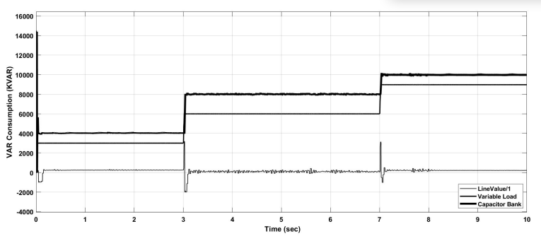

Fig6: step change behavior of VAR in terms of capacitor banks, loads and source.

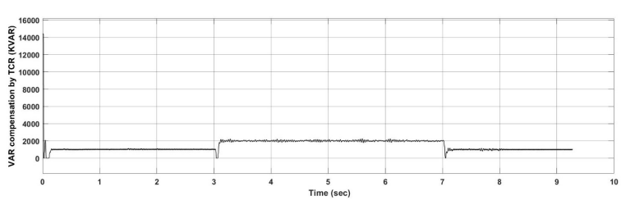

Fig7: Step change behavior of VAR in terms of inductor coil used in TCR branch.

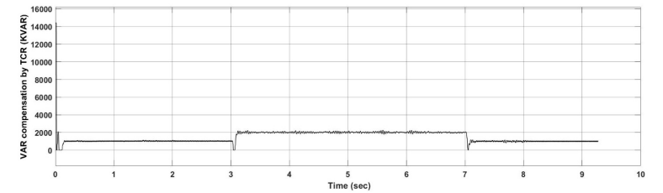

Fig8: graphical representation of power factor of line.

1. **Technical Problem & Solution**

**CE1.12**

During the development of project, I encountered issue which paused the progress of project. I faced an issue during the simulation phase of the project. I noticed over compensation VAR value in the system. I researched about the problems and reasons of the possible problem through online forums. I found out that the problem occurred because of higher chosen number of capacitor unit. I noted that the overloading of power occurred in the system. I consulted with supervisor and personnel having expertise in related field. I found out that the choice of number of capacitor unit should be done following some criteria. I chose the number of capacitor unit by dividing load KVAR value by KVAR value of single capacitor unit. In case of decimal value, I rounded off the value to lower whole number. Also, I compared system line voltage with voltage across capacitor. If the value was equal, I switched on the capacitor. By the application of above method, I overcame the issue of over compensation.

**CE.1.13 Creative Works**

I overcame the issue of over compensation occurred in the system. I used MATLAB/SIMULINK to design and simulate the system model. I communicated with supervisor about the problem to find the solution.

**CE1.14 Team Management**

I consulted with the team members about the project and its required components. I finalized the components for the development of project. I divided the project work into smaller parts and assigned to the team members. I created peaceful working environment for team members to increase productivity of the project. I created a work schedule to complete the project work in provided timeframe. I set regular personal project work for myself and team members to maintain the schedule. I discussed with team members about the encountered problem. I communicated with supervisors and online forums personnel to find solution to the problem faced during the development of project. I prepared documentation of the project and submitted to the supervisor of project illustrating the characteristics and behavior of the project.

**CE 1.15 Code of Conduct**

I followed a set of rules and standard codes while implementing the project. I used an IEC 61850 code for the modeled design of the thyristor controlled reactor (TSR). I also followed an ISO 25119 standard for the simulation using the MATLAB tool.

1. **Summary**

CE 1.16

The objective of the project was to design and simulate thyristor switched capacitor and thyristor-controlled reactor based static VAR compensator using MATLAB/SIMULINK. The research about the components was done via journals, literature review, videos etc. The components were finalized as per the requirement of project. The system model design work was completed using MATLAB/SIMULINK. The parameters were set and simulated using simulation software. The consumption of the VAR was approximated to 0 whereas the VAR consumption of the loads were in the range of 3 to 9 VAR. The outputs obtained from simulations were analyzed under various conditions. The dependability of the power system was improved by employing TSC and VAR over compensating to meet the reactive power needs of inductive loads. On the basis of results obtained, the final conclusion was drafted.

During the stint of project development, I developed personal skills too. I designed system model using MATLAB/SIMULINK. I solved various technical and non-technical problem which improved my problem solving skills. I communicated with supervisor and online forums to find the solution of the problem which enhanced my communication skills.